# EPA/600/B-16/268

# Rapid Benefit Indicator (RBI)

# Spatial Analysis Toolset Manual

Authors: 1Justin Bousquin, 2Marisa Mazzotta, 2Walter Berry

1: U.S. EPA, Office of Research and Development, National Health and Environmental Effects Laboratory, Gulf Ecology Division, Gulf Breeze, FL 32561

2: U.S. EPA, Office of Research and Development, National Health and Environmental Effects Laboratory, Atlantic Ecology Division, Narragansett, RI 02882

## Disclaimer:

This project was supported in part by appointments to the Oak Ridge Institute for Science and Education participant research program supported by an interagency agreement between the U.S. Environmental Protection Agency and the U.S. Department of Energy. This document has been reviewed by the U.S. Environmental Protection Agency, Office of Research and Development, and approved for publication. Any mention of trade names, products, or services does not imply an endorsement by the U.S. Government or the U.S. Environmental Protection Agency. The EPA does not endorse any commercial products, services, or enterprises. This is part of contribution number ORD-018240 of the Atlantic Ecology Division, National Health and Environmental Effects Laboratory, Office of Research and Development, U.S. Environmental Protection Agency.

## Overview:

The Rapid Benefits Indicators (RBI) approach consists of five steps and is outlined in **Assessing the Benefits of Wetland Restoration – A Rapid Benefits Indicators Approach for Decision Makers**,

<https://cfpub.epa.gov/si/si_public_record_Report.cfm?dirEntryId=325010>

hereafter referred to as the “guide”. The guide presents the assessment approach, detailing each step of the indicator development process and providing an example application in the “Step in Action” pages. The spatial analysis tool is intended to be used to analyze existing spatial information to produce metrics for many of the indicators developed in that guide. This spatial analysis tool manual gives you directions on the mechanics of the tool and its data requirements, but does not detail the reasoning behind the indicators and how to use results of the assessment; this information can be found in the guide.

## Requirements:

The Rapid Benefits Indicators (RBI) spatial analysis toolset is run using an ArcGIS Python toolbox. The toolbox must be used within ESRI’s desktop software versions 10.1 or newer. The toolbox is not yet compatible with ArcGIS Pro, and has only been tested on desktop versions 10.1 - 10.5. Operating system and hardware requirements for running this tool are the same as those for using ArcGIS desktop:

<https://desktop.ArcGIS.com/en/arcmap/10.3/get-started/system-requirements/ArcGIS-engine-system-requirements.htm>

## Downloading the Toolset:

The RBI Spatial Analysis Toolset includes a Python toolbox file (.pyt extension) and the associated files required to perform the RBI spatial analysis. It is recommended that these files be downloaded as a package, but portions can alternatively be copied as individual files.

*Recommended –* If downloading from github, go to the [USEPA/Rapid-Benefit-Indicators-Tools](https://github.com/USEPA/Rapid-Benefit-Indicators-Tools) repository, (see Figure 1) and click the green “Clone or download” button, when the drop down window opens the “Download ZIP” button will download all the toolset files as a compressed zip file. Unzip the file to your desired file location.

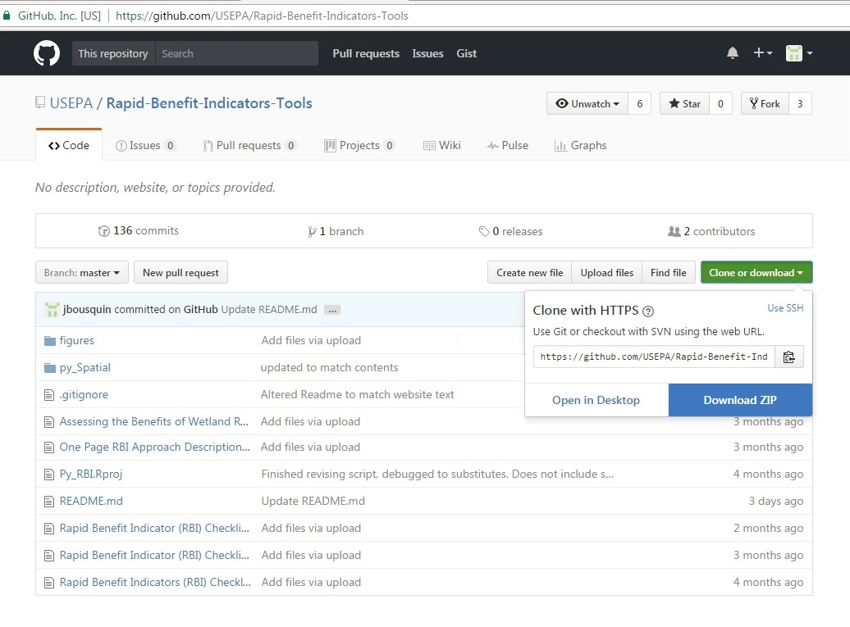

Figure 1 USEPA GitHub repository for RBI, found at <https://github.com/USEPA/Rapid-Benefit-Indicators-Tools>. To download the Spatial Analysis Toolset and all the associated files click “Clone or download” (circled in red) and the “Download ZIP” (circled in red).

*Alternative –* Depending on the requirements of your analysis, you may want individual files. The Python toolbox (.pyt) and standalone python scripts (.py) can be found in the repository subdirectory, py_Spatial or py_standaloneScripts respectively. Clicking the link for the desired file displays the file’s code. Clicking the “Raw” button and then right clicking and selecting “Save as…” will allow for the file to be saved directly. Renaming the file will not affect functionality as long as it has the appropriate extension (.pyt or .py). Associated data and map files have a download option. For full tool functionality you must save these files using the designated name and location relative to the toolbox file.

## Included in the Toolset:

The focus of this manual is running assessments using the seven tools available in the Python toolbox (.pyt) within ArcGIS. In addition to the toolbox, the same functionalities of each tool are also included in standalone python scripts (.py). These scripts are intended for users with knowledge of python who wish to interact directly with the code, the scripts still require the arcpy libraries included with ArcGIS.

For the Python toolbox to have full functionality the toolset requires several other files found in the py_Spatial directory. These files help to streamline your analysis. They include:

.xml files – five files, each named after the tool they refer to, provide additional tool help when using each of the tools within the RBI Spatial Analysis Toolset. Without the .xml files the tool will not have the complete Tool Help including descriptive help for each tool parameter. These files do not impact tool functionality.

NHDPlus files – files in the NHDPlusV21 subfolder are only used for Flood Risk Reduction indicators. The folder contains a File Geodatabase with three data files: BoundaryUnit – a Feature Class with the NHDPlus Boundary Units, Catchment - a Feature Class with catchments, and PlusFlow - a table of upstream/downstream relationships. The Part – Flood Data Download Tool is designed to use these files by default when downloading data from NHDPlus version 2: <https://www.horizon-systems.com/NHDPlus/NHDPlusV2_data.php>

The Full Indicator Assessment Tool is designed to find the downloaded files relative to the toolbox file. The Part – Flood Risk Reduction Tool allows alternative catchments or NHDPlus files or locations to be specified.

.mxd file – a map file is available for download with the tool that includes all the layout formatting required to produce pdf reports. The Full Indicator Assessment Tool is designed to automatically find these files in the same folder as the toolbox file. The Part – Report Generation Tool allows the mapfile (.mxd) to be specified if the file is moved or for alternate formating files.

Installing the Toolbox:

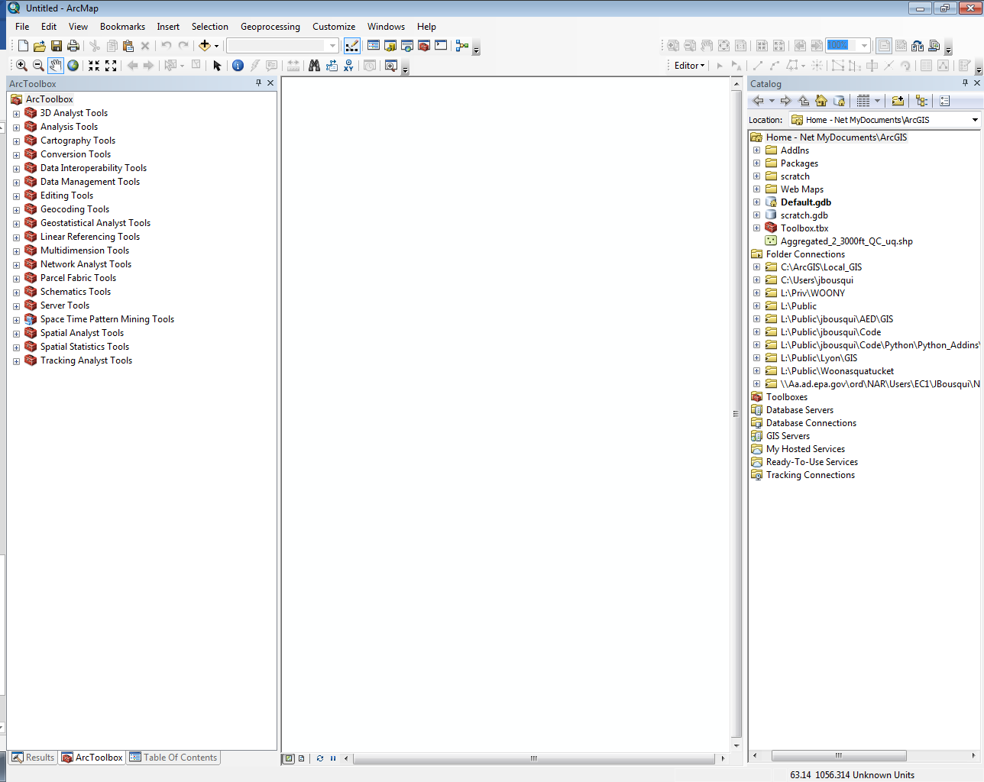Python Toolboxes are easy to install in ArcMap or ArcCatalog and operate just like other geoprocessing tools. To add the toolbox, first click the “Geoprocessing” button on the main ribbon (Figure 2) and choose *ArcToolbox* to open the ArcToolbox window (Figure 3).

Figure 2 Click the Geoprocessing button circled in red and select “ArcToolbox” to open the ArcToolbox window.

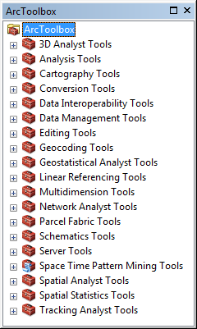

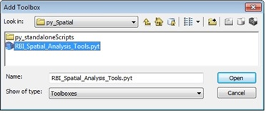Right click inside the ArcToolbox window and choose *Add Toolbox…* to open the Add Toolbox dialog (Figure 4). Use this to navigate to the subfolder py_Spatial inside the download, select the toolbox (.pyt) file and click open.

Figure 4 Add Toolbox dialog, used to navigate to and open the toolbox.

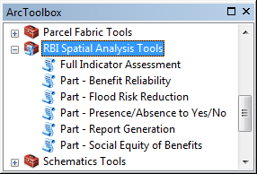

Once added, the toolbox will appear in the ArcToolbox window (Figure 5) alongside other toolboxes, and individual tools within the toolbox will be accessible just like other toolboxes.

Figure 3 ArcToolbox window.

Figure 5 ArcToolbox window with RBI Spatial Analysis Tools Added.

Using the toolbox:

The toolbox is setup to assess five benefits (Reduced Flood Risk, Scenic Views, Environmental Education, Recreation, and Bird Watching) mainly using the Full Indicator Assessment Tool. “Part” tools are also available to help with acquiring input data (e.g., Part – Flood Data Download Tool helps download NHDPlus data), to run individual benefits assessments with added options (e.g., Part – Benefit Reliability Tool has the added option to specify the buffer used) or to perform specific functions on the assessment result data tables (e.g., Part – Report Generation Tool generates a pdf report from the results data table, and the Part – Presence/Absence to Yes/No Tool fills in existing fields in the results data table as Yes or No based on features from a specified dataset being within a specified range of each site).

The next section, **Data Requirements,** describes the datasets used for assessment of each benefit in the Full Indicator Assessment Tool. These descriptions can also be found in the Tool Help for each input field. Each of the seven tools in the toolbox are then described starting with the Full Indicator Assessment Tool.

Data Requirements:

***Required Data***

**Restoration Site Polygons** – The area of the restoration site being assessed. All other input datasets will be re-projected based on the projection used for the restoration sites. All fields and spatial data in this feature layer will be copied from the sites to the output table. The output table from one partial analysis can be used as input to the next.

**Output –** A file name and location must be specified for the dataset that results from the analysis. It is recommended that users create a new file geodatabase and save their output there because the folder location of the output file is also used to save intermediate files. If files with the same names as the intermediates already exist in the specified location, they will be deleted and overwritten.

**Address Points** or **Population Raster** – People in the area around the restoration sites that could potentially receive benefits from site restoration. A buffer of 12 miles around the site will usually be enough, though the range may vary depending on the benefits chosen for assessment. Points representing individual homes should be entered as **Address Points**. Suggested sources include state provided E-991 address data. Grid format representations of population should be entered as **Population Raster**. For the conterminous United States, the EnviroAtlas - Dasymetric Population dataset is recommended:

<https://catalog.data.gov/dataset/enviroatlas-dasymetric-population-for-the-conterminous-united-states>

***Optional Data***

The spatial analysis tool is designed to assess up to five benefits that were developed for urban wetland restoration sites. Each of these has its own specific data requirements.

**Reduced Flood Risk** – Flood risk reduction benefits flow from where they are produced to downstream areas that would otherwise flood. People and structures in areas that flood, defined using the “Flood Zone Polygons”, and within 2.5 miles downstream of wetlands may receive benefits. Tools are designed to determine downstream areas using the NHDPlus files downloaded with the toolset. Before these files can be used, they must be populated using the Part – Flood Data Download Tool. The Full Indicator Assessment Tool assumes NHDPlus files are saved to their default location (~NHDPlusV21\NHDPlus_Downloads.gdb\) relative to the toolbox file. If these data are not in the default location or alternative datasets are used, they must be specified using the Part – Flood Risk Reduction Tool. The process for determining the area that potentially receives benefits starts by selecting catchments sets within a 2.5-mile radius of each site. Next the tool makes a sub-selection of those catchments sets that are downstream from catchment(s) that overlap each site based on values in the “Relationship Table”. Once a catchment falls completely outside 2.5 miles of the site no further downstream catchments are included even if the stream network flows back into the area within 2.5 miles of the site. However, since the stream network may curve and loop around within 2.5 miles of the site, the length of the stream network included will typically exceed 2.5 miles. Both “Dams and Levees” and “Wetlands” are features that may act as substitutes, also reducing flood risk. Only dams downstream of the site are counted. All wetlands within a 2.5-mile range upstream and downstream are considered.

Table 1 Optional inputs for assessing Reduced Flood Risk Benefits.

|  |  |  |  |
| --- | --- | --- | --- |
| **Parameter** | **Explanation** | **Data Type** | **Suggested Source** |
| Flood Zone Polygons | Dataset that defines flood zones (e.g. 100-yr or 500-yr) where flooding occurs | Feature Layer | FEMA, and/or NOAA |
| Wetland Polygons | Vector dataset that defines existing wetlands | Feature Layer | National Wetlands Inventory (NWI) |
| Dams/Levees | Point, line or polygon dataset defining flood prevention infrastructure | Feature Layer | USGS NHDPlus, and/or FEMA |
| NHD+ Catchments | Dataset that defines catchments around the restoration sites | Feature Layer | Default ~NHDPlus_Downloads.gdb\  Catchment |
| NHD Join Field | Field that holds the ID associated with the catchment in the relationship table | Field | Default “FEATUREID” |
| Relationship Table | Table with to/from COMID fields corresponding to the NHD Join Field for upstream/downstream catchments | Table | Default ~NHDPlus_Downloads.gdb\  PlusFlow |

**Scenic Views –** Scenic view benefits flow from aesthetically pleasing landscapes outward to surrounding areas. Residents in the surrounding area and people moving through, assessed using “Trails” and “Roads” route datasets, may receive benefits. Existing wetland features are considered substitutes that may already benefit people. However, other types of greenspace, defined using the “Landuse/Greenspace” dataset, are complements where greater landscape variety increases a view’s value. The user has the flexibility to choose what field and values represent value adding greenspace in the Landuse/Greenspace dataset.

Table 2 Optional inputs for assessing Scenic View Benefits.

|  |  |  |  |
| --- | --- | --- | --- |
| **Parameter** | **Explanation** | **Data Type** | **Suggested Source** |
| Trails (hiking, biking, etc.) | Point, line or polygon dataset that defines other places people may receive benefits | Feature Layer | NPS, State agencies, or NGOs |
| Roads (streets highways, etc.) | Point, line or polygon dataset that defines other places people may receive benefits | Feature Layer | Tiger, E911 and/or OpenStreetMap |
| Wetland Polygons | Vector dataset that defines existing wetlands | Feature Layer | National Wetlands Inventory (NWI) |
| Landuse/Greenspace Polygons | Vector dataset that defines alternative greenspace that may add value | Feature Layer | State agencies, and/or NOAA |
| Greenspace Field | Field identifying greenspace landuse | Field | user specified |
| Greenspace Field Values | Values in the field which are greenspace | Values | user specified |

**Environmental Education –** Environmental education benefits are the only ones that can be assessed without a population dataset (addresses or population raster). The “Educational Institutions” dataset is used instead and can include public schools as well as early education institutions like pre-k or daycare. Existing wetland features are considered substitutes that may already benefit people.

Table 3 Optional inputs for assessing Environmental Education Benefits.

|  |  |  |  |
| --- | --- | --- | --- |
| **Parameter** | **Explanation** | **Data Type** | **Suggested Source** |
| Educational Institution Points | Point dataset that defines education institutions that may receive benefits | Feature Layer | State department of education |
| Wetland Polygons | Vector dataset that defines existing wetlands | Feature Layer | National Wetlands Inventory (NWI) |

**Recreation –** Recreation benefits require people to travel to the site where recreation opportunities are to benefit. People within walking or driving distance of the site are assumed to be able to benefit. The presence of “Trails” or “Bus Stops” dataset features also increase who could benefit by making the site accessible by alternative modes of transportation. Existing wetland features are considered substitutes that may already benefit people. However, other types of green or open space adjacent to the restoration site are complements, as these may increase the types of recreational opportunities available.

Table 4 Optional inputs for assessing Recreation Benefits.

|  |  |  |  |
| --- | --- | --- | --- |
| **Parameter** | **Explanation** | **Data Type** | **Suggested Source** |
| Trails (hiking, biking, etc.) | Point, line or polygon dataset that defines trails that help people access benefits | Feature Layer | NPS, State agencies, and/or NGOs |
| Bus Stop Points | Point, line or polygon dataset that defines bus stops that help people access benefits | Feature Layer | State department of transportation or OpenStreetMap |
| Wetland Polygons | Vector dataset that defines existing wetlands | Feature Layer | National Wetlands Inventory (NWI) |
| Landuse/Greenspace Polygons | Vector dataset that defines alternative greenspace that may add value | Feature Layer | State agencies, and/or NOAA |
| Greenspace Field | Field identifying greenspace landuse | Field | user specified |
| Greenspace Field Values | Values in the field which are greenspace | Values | user specified |

**Bird Watching** – Bird watching benefits flow from where birds are located outward to surrounding areas where people can see them. Bird Watching benefits can be received in the surrounding area by residents or by people moving through on trails or roads (i.e., via trails and roads).

Table 5 Optional inputs for assessing Bird Watching Benefits.

|  |  |  |  |
| --- | --- | --- | --- |
| **Parameter** | **Explanation** | **Data Type** | **Suggested Source** |
| Trails (hiking, biking, etc.) | Point, line or polygon dataset that defines other places people may receive benefits | Feature Layer | NPS, State agencies, and/or NGOs |
| Roads (streets highways, etc.) | Point, line or polygon dataset that defines other places people may receive benefits | Feature Layer | Tiger, E911 and/or OpenStreetMap |

In addition to the five optional benefits that can be assessed, the restoration site can also be assessed for its potential to deliver benefits in a socially equitable way and reliably into the future.

**Social Equity** – The social equity of restoration sites can be compared for each benefit based on who is expected to benefit, but these will typically be similar across different benefits so it is recommended that users run social equity once for each site.

Table 6 Optional inputs for assessing the social equity of benefits.

|  |  |  |  |
| --- | --- | --- | --- |
| **Parameter** | **Explanation** | **Data Type** | **Suggested Source** |
| Social Vulnerability | Dataset that defines the social vulnerability of different areas | Feature Layer | Social Vulnerability Index (NOAA, CDC or census) |
| Vulnerability Field | Field designating population vulnerability | Field | user specified |
| Vulnerable Field Values | Values in the field which are vulnerable | Values | user specified |
| Buffer Distance | Value and units | Distance | Default |

**Reliability –** A restoration site that will persist further into the future is rated as higher priority than a comparable site that is not expected to persist into the future.

Table 7 Optional inputs for assessing the reliability of benefits.

|  |  |  |  |
| --- | --- | --- | --- |
| **Parameter** | **Explanation** | **Data Type** | **Suggested Source** |
| Conservation Lands | Vector dataset defining areas to be conserved or otherwise protected against future threats and development | Feature Layer | State Planning Organizations |
| Conservation Field | Field designating protected areas | Field | user specified |
| Conservation Types | Values in the field which are protected | Values | user specified |
| Buffer Distance | Value and units | Distance | 500 ft |

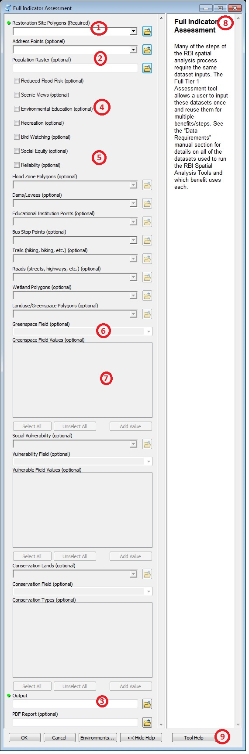**Using the Full Indicator Assessment Tool**

Many of the steps of the RBI spatial analysis process require the same dataset inputs. The Full Indicator Assessment tool allows a user to input these datasets once and reuse them for multiple benefits/steps. See the “Data Requirements” manual section for details on all of the datasets used to run the RBI Spatial Analysis Tools and which benefit uses each.

Datasets are added either by dragging and dropping a layer into the fillable space or by navigating the tool to the dataset using the corresponding open icon to the right.

(1) **Restoration Site Polygons**, (2) **Address Points** or **Population Raster**, and the (3) **Output** file must always be specified for the tool to run. Either Address Points or the Population Raster are needed to run the analysis, and once entered the other will become gray and non-fillable.

Check boxes are clicked to select which benefits will be assessed (4: Reduced Flood Risk, Scenic Views, Environmental Education, Bird Watching, Recreation) and if additional site metrics (5: Social Equity, Reliability) will be calculated. As boxes are checked, the datasets required for each will go from gray to fillable. This feature of the tool helps to clarify what the data requirements of your desired analysis. If a dataset is not entered or associated files are not available the tool will execute, but skip some metrics.

Flood Zone, Dams/Levees, Educational Institutions, Bus Stops, Trails, Roads, Wetlands, Landuse/Greenspace, Social Vulnerability, and Conservation Lands datasets can be in a geodatabase, shapefile, or feature layer selection.

The Landuse/Greenspace, Social Vulnerability, and Conservation Lands datasets each require certain values in certain fields to be specified. This increases flexibility and limits pre-processing. For example, in Landuse/Greenspace the tool only uses greenspace classified features. The classification (6) **Field** within your landuse dataset and its selected greenspace (7) **Values** are user-specified, allowing for different datasets and greenspace classifications.

In addition to the output table, the tool can also create a pdf report when a new PDF Report file name is entered.

All tools have (8) Help guidance and a (9) Tool Help sheet when downloaded as part of the tool package.

Figure 6 Full Indicator Assessment Tool

|  |  |  |  |
| --- | --- | --- | --- |
| **Benefit** | **Indicator** | **Text** | **Field Name** |
| Flood Risk | How Many Benefit? | 2.5 mi downstream of site and in flood zone | FR_2_cnt |
| Flood Risk | Service Quality | Area of restoration site (acres) | FR_3A_acr |
| Flood Risk | Service Quality | Features that increase retention volume? | FR_3A_boo |
| Flood Risk | Scarcity | Dams and levees 2.5 mi downstream? | FR_3B_boo |
| Flood Risk | Scarcity | Wetlands within 5 mi (number or % area) | FR_3B_sca |
| Flood Risk | Preferences | Are people worried about flood risk? | FR_3D_boo |
| Scenic Views | How Many Benefit? | Number within 160 ft of site | V_2_50 |
| Scenic Views | How Many Benefit? | Number within 160-325 ft of site | V_2_100 |
| Scenic Views | How Many Benefit? | Weighted number who benefit (70/30) | V_2_score |
| Scenic Views | How Many Benefit? | Are there roads or trails within 325 ft of site? | V_2_boo |
| Scenic Views | Service Quality | Aesthetic features or characteristics? | V_3A_boo |
| Scenic Views | Scarcity | Wetlands or water within 650 ft (number or %) | V_3B_scar |
| Scenic Views | Complements | Natural land use types within 650 ft (types) | V_3C_comp |
| Scenic Views | Preferences | Will people find it aesthetically pleasing? | V_3D_boo |
| Environmental Education | How Many Benefit? | Educational institutions within 0.25 mi of site | EE_2_cnt |
| Environmental Education | Service Quality | Features/habitat/wildlife of educational interest? | EE_3A_boo |
| Environmental Education | Scarcity | Wetlands within 0.5 mi of the site | EE_3B_sca |
| Environmental Education | Complements | Educational facilities or infrastructure on site? | EE_3C_boo |
| Environmental Education | Preferences | Will people prefer characteristics of the site? | EE_3D_boo |
| Recreation | How Many Benefit? | Number within 1/3 mi of the site | R_2_03 |
| Recreation | How Many Benefit? | Are there bike paths within 1/3 mi of site? | R_2_03_bo |
| Recreation | How Many Benefit? | Are there bus stops within 1/3 mi of site? | R_2_03_b2 |
| Recreation | How Many Benefit? | Number within 0 to 0.5 mi of site | R_2_05 |
| Recreation | How Many Benefit? | Number within 0.5 to 6 mi of site | R_2_6 |
| Recreation | Service Quality | Total area of green space around site | R_3A_acr |
| Recreation | Scarcity | Green space within 2/3 mi of site | R_3B_sc06 |
| Recreation | Scarcity | Green space within 1 mi of site | R_3B_sc1 |
| Recreation | Scarcity | Green space within 12 mi of site | R_3B_sc12 |
| Recreation | Complements | Infrastructure supporting recreational activities? | R_3C_boo |
| Recreation | Preferences | Are there additional features on the site? | R_3D_boo |
| Bird Watching | How Many Benefit? | Number within 0.2 mi of site | B_2_cnt |
| Bird Watching | How Many Benefit? | Are there roads or trails within 0.2 mi of site? | B_2_boo |
| Bird Watching | Service Quality | Will the site support rare or unique species? | B_3A_boo |
| Bird Watching | Complements | Supporting infrastructure or habitat on site? | B_3C_boo |
| Bird Watching | Preferences | Will people be interested in birds at the site? | B_3D_boo |
| Social Equity | Percent area of buffer with selected vulnerable field value | | High |
| Reliability | Percent area of buffer with selected conserved field value | | Conserved |

Table 8 Indicator field names in the results table

|  |  |
| --- | --- |
| **Field Name** | **Description** |
| FR_zPct | Percent area around site that is flood zone |
| FR_zDown | Area of downstream flood zone |
| FR_zDoPct | Percent flood zone in area which is downstream |
| FR_sub | Count of substitute features in FR_3B_boo |
| “SOVI values” | A field is created for each unique value that isn’t selected as vulnerable |
| Threatened | Features in the conservation layer that aren’t selected as “conserved” |

**Using Partial Assessment Tools**

Table 9 Field names in the results table that are not included as indicators

The Full Indicator Assessment tool allows a user to run an assessment from start to finish but is streamlined with certain defaults. The “Part” assessment tools perform processes within the Full Indicator Assessment, but allow the user more flexibility to specify additional parameters or inputs.

**Part – Flood Data Download Tool**

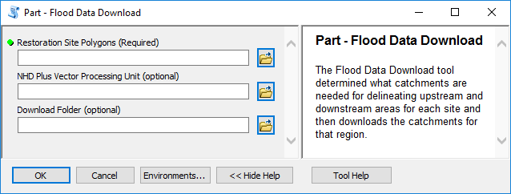

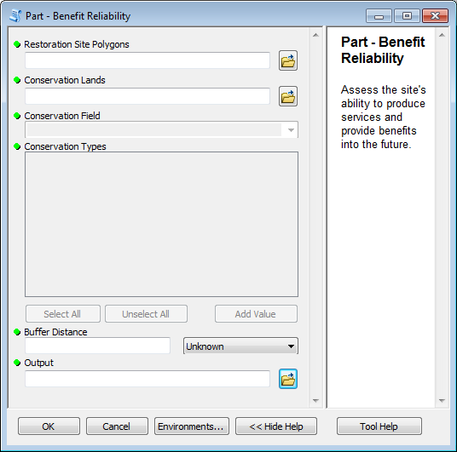**Part - Benefit Reliability Tool**

The Benefit Reliability tool calculates the reliability of site benefits in the same way as the Full Indicator Assessment Tool, but the user can designate a custom buffer distance around the restoration site that will be considered to determine the reliability, instead of the default 500 ft used in the Full Indicator Assessment.

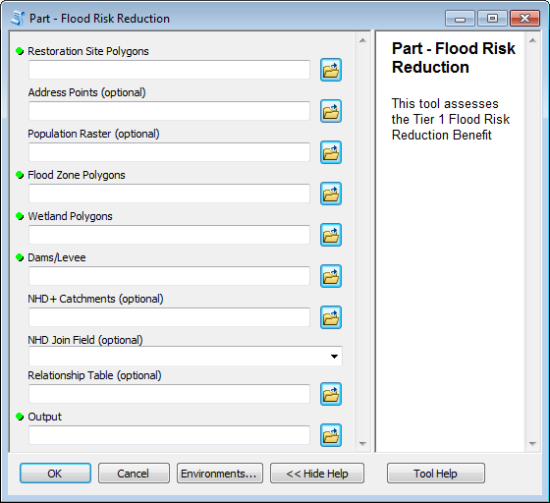

**Part – Flood Risk Reduction**

The Flood Risk Reduction tool calculates indicator metrics for flood risk reduction benefits in the same way as the Full Indicator Assessment Tool, but the user is able to specify the catchment dataset to use and the field in that dataset that corresponds to a COMID field in the specified relationship table. Whereas the Full Indicator Assessment assumes the NHD+ dataset was downloaded and saved with the tool package, this partial assessment tool lets users specify their own catchments.

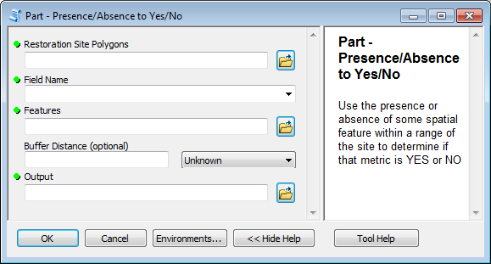**Part – Presence/Absence to Yes/No Tool**

The Full Indicator Assessment tool uses the same functionality as the Presence/Absence to Yes/No tool, but that functionality is not directly accessible. For example, for recreation benefits, this same functionality is used to determine if there are bike paths within 1/3 miles of the site. If the “Trails” dataset passes within the 1/3 mile-buffer around a site the “R_2_03_tb” field gets a “YES”, otherwise it gets a “NO.”

There are several indicators that are measured as yes or no (see table below). The Presence/Absence to Yes/No tool is designed to work with vector datasets to put metrics to these indicators and populate the output table where the Full Tier Assessment tool does not.

Table 10 Field names in the results table that correspond to Yes/No indicaotrs

|  |  |  |  |
| --- | --- | --- | --- |
| **Benefit** | **Step** | **Indicator** | **Field** |
| Flood Risk | Service Quality | Features that increase retention volume? | FR_3A_boo |
| Scenic Views | Service Quality | Aesthetic features or characteristics? | V_3A_boo |
| Environmental Education | Service Quality | Features/habitat/wildlife of educational interest? | EE_3A_boo |
| Environmental Education | Complements | Educational facilities or infrastructure on site? | EE_3C_boo |
| Recreation | Complements | Infrastructure supporting recreational activities? | R_3C_boo |
| Bird Watching | Service Quality | Will the site support rare or unique species? | B_3A_boo |
| Bird Watching | Complements | Supporting infrastructure or habitat on site?” | B_3C_boo |

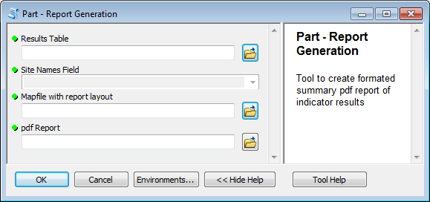**Part – Report Generation Tool**

The Report Generation tool uses the Results Table (Output from other tools) to create a PDF Report in the same way as the Full Indicator Assessment Tool, but the user is able to specify the Mapfile (.mxd) with the report layout in it. The user is also able to specify a field in the results table with names for the sites.

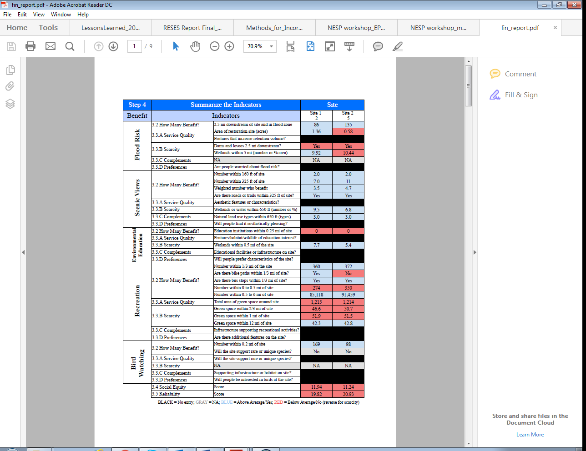

Figure XX Example pdf report output page

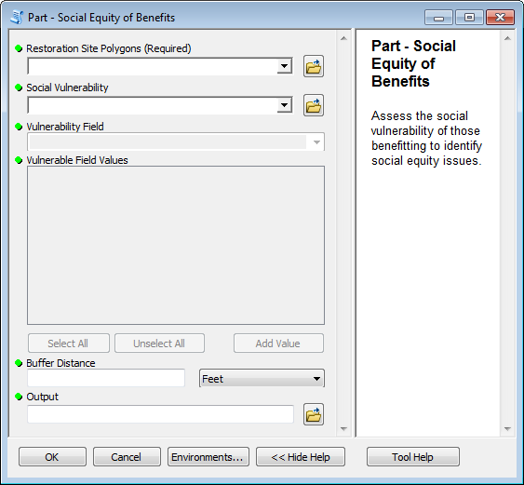**Part – Social Equity of Benefits Tools**

The Social Equity of Benefits tool calculates the social equity of site benefits in the same way as the Full Indicator Assessment Tool, but users are able to designate their own buffer distance around the restoration site that will be considered to determine the reliability instead of the default. The default used by the Full Indicator Assessment is the largest reasonable distance someone receiving one of the selected benefits could be from the site and still receive benefits [flood risk = 2.5 miles, recreation = 0.2 miles, bird watching = 100 meters, etc.].

**Frequently Asked Questions and Solutions to Common Errors**

*Do I have to know GIS to run the RBI Spatial Analysis Tools?*

It is not mandatory to have a high level of GIS training to begin working with the tool, but a basic familiarity with ArcGIS may help avoid more common mistakes.

*At what scales can the tool be applied?*

The tool was initially designed to be used to compare wetland restoration sites within the same watershed. The rapid nature of the indicators makes it so that differences between watersheds may be lost, so although the tool may function on larger scales the analyst should be cautious of comparing those results.

*How long will it take to perform the assessment?*

There are many factors that influence the length of time the assessment takes. Usually assembling and pre-processing the datasets to run in the assessment tool is the most time consuming step. Run time for the tool varies depending on the size of analysis, size of input datasets and specifications of the computer system being used.

*Do I need an internet connection to run the RBI Spatial Analysis Tools?*

An internet connection is required to initially download the toolset and to download NHDPlus data using the Part – Flood Data Download Tool, but this data is only required to assess flood risk reduction benefits and only has to be downloaded once.

*Do I need the spatial analyst extension?*

The spatial analyst extension is only required if using a population raster dataset.

*What radius around the site does the Full Indicator Assessment Tool use for reliability of benefits?*

The Full Indicator Assessment Tool uses a default buffer distance of 500 feet.

*What radius does the Full Indicator Assessment Tool use for social equity of benefits?*

The default distance (also used for Buffer Distance if the parameter is not specified in the Part – Social Equity of Benefits Tool) is determined based on the selected Benefits being assessed. When a benefit with longer delivery pathways

NHDPlus data files are periodically updated and given new version numbers. If an old version number is used the toolbox will not be able to download and unzip the catchment or flow table correctly and an error will occur when the toolbox tries to open the file (Figure xx). The toolbox is periodically updated with new version numbers so downloading a newer version may resolve the issue. Otherwise the file can be downloaded manually from: <https://www.horizon-systems.com/NHDPlus/NHDPlusV2_data.php>

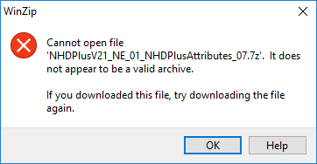

^The downloaded file is not valid. Try manually downloading the correct file. This occurs when a new version of the NHD Plus flow data or catchments has been released.

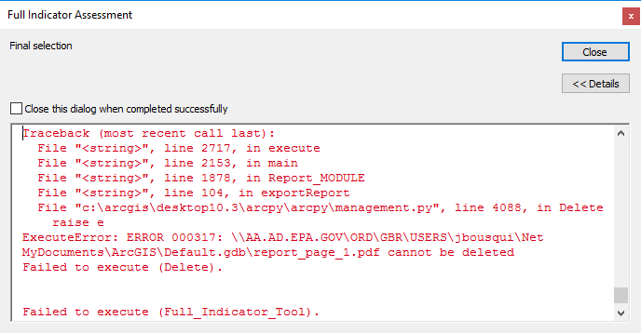

^The tool generates a pdf for each page and deletes it after the page has been added to the report. This error will appear if the pdf page is unable to be deleted.

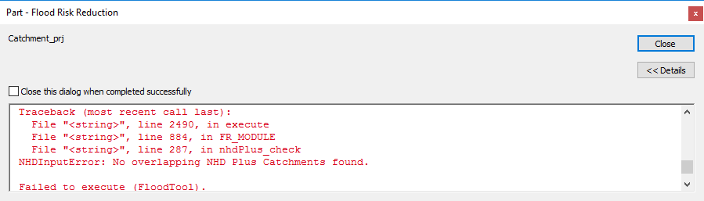

Problem:

I check “Reduced Flood Risk” but it doesn’t calculate any.

Solution:

Run the ‘Part – Flood Data Download’ tool to download NHD Plus data.

‘No overlapping NHD Plus Catchments found.’

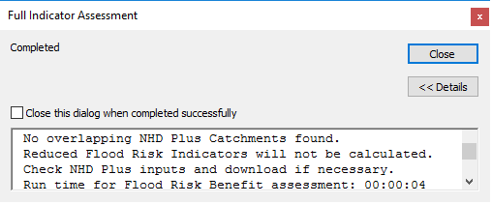

Warning:

